Use Case Realisation Report - Manage Project
FOR
Volunteer Management System
(VMS)

CLIENT
PROJECT | Volunteer Management System (VMS)
TITLE | Use Case Realisation Report - Manage Project
VERSION | 0.1a
DATE | 13-Aug-2011
 | ORIGINATOR
 | Name / Signature | Team 8S
 | APPROVAL
 | Name / Signature | Phung Kim Cuong, Dio
Institute of Systems Science |  | Document Reference
25 Heng Mui Keng Terrence  Singapore 119615 |  | VMS/PM-1.3.1/1

 | Acceptance
 | Customer Signature |  | Customer Signature
 | Name & Designation |  | Name & Designation
 | Date & Company Stamp |  | Date & Company Stamp

Revision History

Date | Version | Description | Author
12-Jun-2011 | 0.1a | Creation | Team 8S
 |  | Refer to amendment history

Table of Contents

Use Case Realisation Report - Request for Certificate 3
1. Brief Description 3
2. Flow of Events 3
2.1 Standard Flow 3
2.2 Exceptions 3
3. Interaction Diagrams 4
3.1 Request for Certificate 4
4. Participating Objects 4
5. Class Diagrams 4
6. Derived Requirements 4
ANNEX D Amendment History 5

Use Case Realisation Report - Manage ProjectCertificate

Brief Description
The use case enables the Volunteer to request for certificate of project that he/she has participated in.

Flow of Events
The standard flow of events for this use case and any exceptions are described in the following subsections. See section 3.1 for an overview of the participating Actors and Domain Objects.

Standard Flow
Precondition: BrowseProjectDetails usecase has been executed
This use case provides the user interface related functionality that will be provided to the Volunteer as follows:
- When the volunteer clicks ‘RequestCertificate’ button, the method requestProjectCertificate() of ProjectController is triggered.
- The ProjectController will use the method getProjectStatus() to get current status of this particular project
- ProjectController will use the getParticipantsbyProjectId() method to get a list of Volunteers that have been registered in the project
- ProjectController will use its method validateCertificateApplicant() to validate if the certificate applicant is qualified to request for certificate of this project
- If the project status is not active, the ProjectController will use the displayMsg() method of ProjectDetailsScreen to display error message ‘The Project status is incorrect’
- If the username is not found among the project participants, the ProjectController will use the displayMsg() method of ProjectDetailsScreen to display error message ‘Only Project Participants can request for the certificate’
- After validation, the ProjectController will use the create() method of CertificateRequest object to create a new CertificateRequest Object and save to database
- ProjectController will use the displayMsg() method of ProjectDetailsScreen to display success message ‘The certificate request has been sent for Project Manager review’
- The use case terminates

Exceptions
The following exceptions were identified:

Interaction Diagrams

Request for Certificate

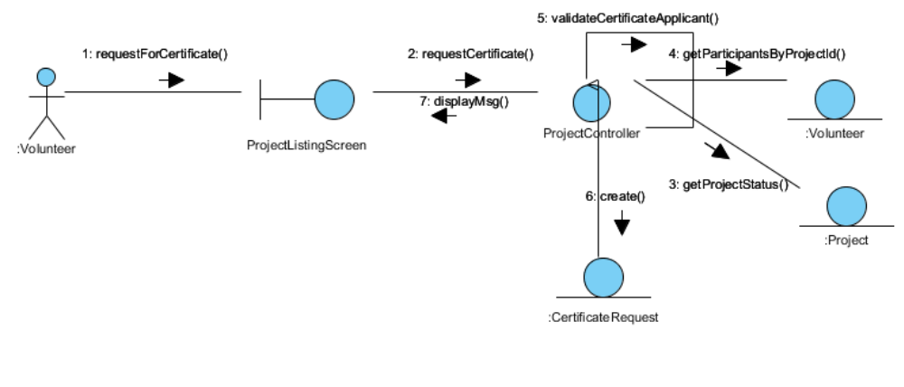

Participating Objects

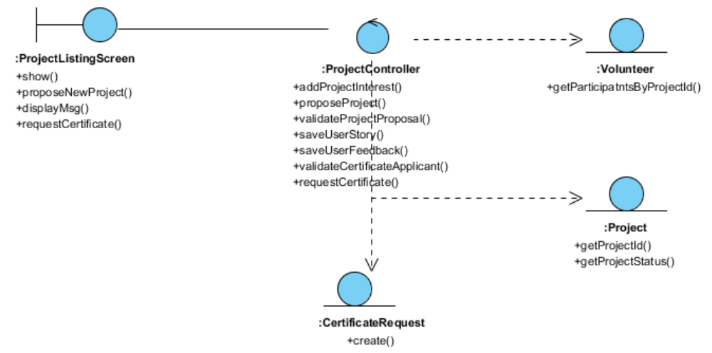

Class Diagrams

Derived Requirements

ANNEX D Amendment History

This is a record of all amendments made to the Document.
Version | Chapter / Section | Page No | Notes of Amendments or Changes

